**INTRODUCTION**

[1]

MSN Messenger was first launched on July 22, 1999. In 2005, it was rebranded as Windows Live Messenger providing services across multiple platforms that ran on a Microsoft Operating System. At launch, MSN was available to any user with a Hotmail or an AOL (America Online) account allowing users to exchange online messages and emails. AOL predicted the rise of instant messaging services and prevented users with AOL id from signing up with MSN. Since then, users required either Hotmail or a Windows Live id to gain access to MSN. This made MSN exclusive to Microsoft users, even though signing up with Microsoft was free and users could have both AOL and MSN accounts. However, even though AOL was one of the first IM service, MSN took over and gained much more users due to Microsoft’s worldwide prestige. By 2003, MSN had already crossed 100m users whereas AOL had just over 10m users [3]. This gap only increased over time and MSN was soon the preferred IM. However, over time MSN lost its place as the World Wide Web saw the rise of multiple newer upgraded messaging services. The key reason for this was that the foundation was laid out for new designers and they improved on along with bringing newer features. MSN was discontinued in 2013 after Microsoft acquired Skype and decided to redirect their users from MSN to Skype. Here, we take a look at MSN and what made it one of the most used IM service before the foreseen boom in the IM market.

MSN was targeted at a very broad audience, ranging from general public to employees at Microsoft itself. It allowed anyone with a computer and an internet connection to communicate over short and long distances. It was used to communicate with family members in different nations or to collaborate with a colleague sitting two desks away.

It was available on the following platforms [1]:

* Windows OS
* Mac OS
* Windows Phone
* Symbian OS
* Blackberry OS
* iOS
* Xbox 360

# ***FEATURES***

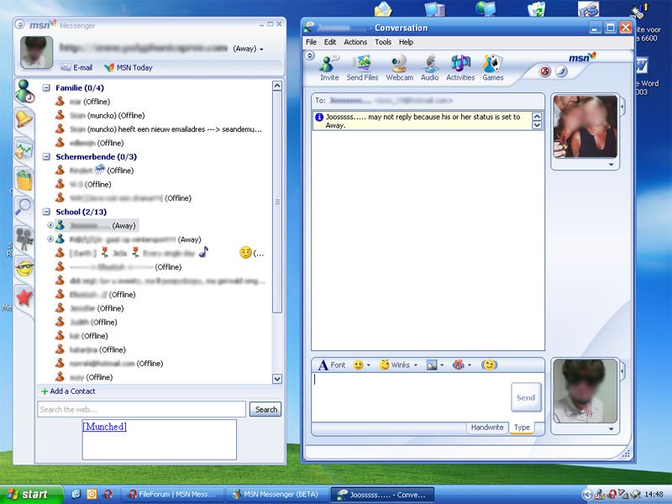

The basic layout of MSN Messenger

MSN let users add contacts by clicking the ‘Add a Contact’ button which asked for another users email address. Once added, you could categorize the contact into different groups as shown in the above image. To chat, users clicked the contact from the left box in the image, which opened a chat window (the right box in the image). Users could send private messages, files, call the other user or setup a webcam along with the chat. Users could also invite more contacts to a private chat to make it a conference or a group chat. Users could adjust their text font, send smileys (emoticons) or winks (which was later integrated into emoticons).

Additional features included [1]:

* Appear Offline
  + Users could appear offline to a particular contact or a group while still appearing online to others. Later versions of MSN allowed users to block a contact, which would not let the ‘blocked contact’ communicate with the user anyhow.
* Offline Messaging
  + Users could message an offline contact, the contact would receive the message as soon as they log into MSN the next time.
* Social Network Integration
  + After the rise of Facebook, social networking was defined at a whole new level. Everyone has a Facebook, and MSN/Windows Live provided integration of such social networking accounts (along with LinkedIn, MySpace, etc) to that of MSN. MSN imported all of the contacts from these social networking accounts, along with giving the user the ability to post updates and photos directly from MSN itself.
* Album Viewer
  + Windows Photo Gallery was attached to the users email. This let users view their contacts’ photo albums from Facebook or SkyDrive in full screen as well as slideshow mode. It also supported commenting on pictures or tagging people.
* Games and Applications
  + MSN also offered games and activities that users could play with their contacts. This was done via clicking the ‘Games’ or ‘Activity’ icon from the top panel of the Conversation window.
  + MSN offered an application called ‘Whiteboard’. Users could do just anything on here (draw, write, play tic-tac-toe, etc).
* Messenger Companion
  + The companion was an add on for Microsoft’s Internet Explorer that let users know if any of their contacts visited or shared anything from the webpage that the user is currently on.
* XBOX 360 Integration
  + Windows Live Messenger was integrated to Microsoft’s Xbox 360 gaming console just like a lot of other Microsoft applications once Xbox 360’s user interface was changed to resemble Windows 8. This let gamers chat with each other and a special keyboard was also designed that fit the controller.

# ***TECHNOLOGIES***

Microsoft is a huge company and is keeps it’s behind the scene work secure from the general public. There is no official statement as to what language MSN was written it, but it is assumed to be written in C. Any language that supports Sockets (to transfer data over IP) can be used to code an IM. Almost all programming languages support this feature, and C allows developers to access the system and it’s servers with ease.

MSN uses Microsoft Notification Protocol (MSNP), developed by Microsoft for MSN and later Skype to connect to. It also supports third-party clients. It runs between the MSN client and the servers and provides the following core services [2]:

* + - Authenticated User Logon
    - Adding/Deleting from user’s contact list
    - Changing User’s availability status
    - Receipt of asynchronous, real time, online state change notifications of user’s contacts
    - Delivering/Receiving asynchronous, real-time messages to/from other users
    - Configuration of user’s access permissions

MSN Messenger Servers:

* Dispatch Server (DS)
  + This is the initial point of connection between client and server. It determines which Notification Server is associated with the client making the connection[2]
* Notification Server (NS)
  + This is the primary server component. The client connects to the NS after referral from DS is complete. NS authenticates, synchronizes user properties and exchanges asynchronous event notifications. (Eg. State changes, Switchboard server requests, etc.) [2]
* Switchboard Server (SS)
  + Through the SS, clients can establish lightweight communication sessions without requiring a direct communication network. When a client wishes to communicate with another client, SS send its message to NS , which then refers the client to a SS. Once this connection is established, the “destination” client then receives a notification from its NS to connect to the same SS. [2]

# USE CASES

* + - Adding a Contact
      * User clicks on the ‘Add a Contact’ symbol (with the green plus sign)
      * User then inputs their contact’s email address, phone number (optional) and category (optional).
      * User sends an optional invitational message and clicks on the ‘send invitation’ button.
    - Starting a conversation with a contact
      * User double clicks the contact name from their contact list, which opens up a private conversation window with the selected contact.
      * User types their message in the smaller text box next to their profile picture and clicks ‘Send’ to send the message. (The bigger box displays the ongoing conversation)
    - Adding more contacts to an ongoing conversation
      * User clicks on the ‘Invite’ icon from the top panel of the conversation window.
      * User can then select from a list of online contacts or search for a contact from their friend list.
      * User clicks ‘Select’ from the list and the selected contact is sent an invitation to join the conversation.
    - Audio Call a contact
      * User double clicks the contact to make a call to.
      * User selects the ‘Audio’ icon from the top panel in the conversation window.
      * An audio call is now made to the attached phone number of the contact.
    - Start a webcam feed
      * Once in conversation window with a contact, user clicks on the ‘Webcam’ icon on the top panel.
      * A new window opens that displays their live webcam feed. To view your contact’s feed, they have to perform the same task and another window pops up with the contact’s feed.
    - Sending a file to a contact
      * Once in conversation window, select ‘Send Files’ from the top panel.
      * A window opens up where the User browses through their files on the hard disk, and selects it.
      * User clicks ‘Send’ and the file is now sent to the contact.

# ***ANALYSIS***

About a decade ago, the strengths of MSN were the following –

* + - Easily understandable UI (layout, buttons)
    - Ability to send messages to anyone online or offline.
    - Ability to organize contacts into groups.
    - Group chats
    - Ability to share files (multimedia, pdf, doc, ppt, etc).
    - Ability to video call and video conference.
    - Ability to call a phone number.
    - Ability to play multiplayer games with friends (chess, checkers, solitaire, etc.).
    - Ability to chat with anyone with a yahoo account (since 2006), with a Facebook account (since 2010), and friends with XBOX Gamertags (after integration with Xbox). [4]
    - Ability to view a friend’s photo album (once linked with their email).
    - Ability to view and comment on friend’s activity on a particular webpage (with the Companion app).
    - The Whiteboard.

Almost all of the mentioned features above are not really regarded as strengths in today’s world of messengers; they were quite remarkable additions which are just common features available in today’s messaging applications.

The only standout amongst these features is the Whiteboard. I have not seen any recent IM offer a similar application. It is like Microsoft paint and lets both users (in conversation) to draw, write, color or even scribble on a white area.

Like any other program, MSN had weaknesses too.

* + - Anyone could send you an invitation or a message.
    - Anytime a new version is released, MSN had to be updated to be used.
    - Viruses could be shared via the ‘Send Files’ option.
    - Possibility of image theft as your profile image is displayed to anyone who searches you.

However, the strengths of MSN outweighed its weaknesses and it quickly gained popularity. Users could block anyone who they did not want to talk to. They could use an anti-virus to stay protected against corrupted files (always scanning them before opening). Updating MSN was not really a weakness, but something that could be worked upon.

Here is an analysis of MSN based on the MoCA framework.

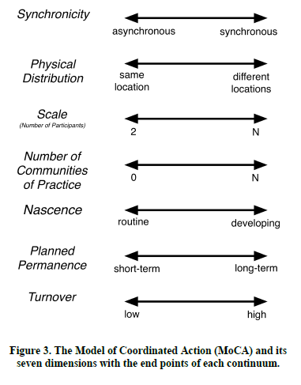[5]

MSN works asynchronously as it allows its users to send/receive messages to anyone online or offline. However, some features (audio calling, webcam calls, games, whiteboard) require the other user to be online, making it synchronous as well.

It allows you to message anyone with an email address, not requiring both users presence at the same location. All of the features work this way and MSN can be used from different locations around the world.

Users can host conferences, and chat (text, audio and video) with multiple other users (N number of users) at the same time at different locations.

New users are provided with help and guidelines through Microsoft to learn the features of MSN. Users can also learn about new features from friends who have used MSN in the past. The number of communities of practice here is 2 (Microsoft/internet assistance, friends and family).

Once the user learns to operate MSN, they are required to perform the same steps each time (some use cases are provided in the above section). It is routine work and users are not expected to keep learning throughout the years using MSN.

Collaboration on MSN is short-term. It is only used for communication and there is no way to store any audio/video conversations or whiteboard, although text conversations are archived and can be viewed by both or all users in the particular chat.

The turnover rate is high as users host private conversations with other users, and chat/collaboration is closed once user logs out.

# ***CONCLUSION***

MSN proved to be one of the most successful instant messengers during its early years. Microsoft was getting popular and so were applications owned by them. MSN allowed people to communicate and collaborate through various ways. Microsoft’s popularity kept rising and it was expanding at a rapid rate, eventually buying out their IM competitor: Skype. Microsoft decided to adopt Skype as their primary IM service and eventually shut all MSN service in 2014.

MSN laid out a design that many following IM’s adopted and improvised upon. Although MSN was popular while it was only one of the few in the market, users preferred newer IM’s as a part of advancement. A lot of users shifted to Facebook and quickly adapted to their own IM as it offered more than MSN and merely because people said “Facebook me” and not “MSN me”. We take a look at the Facebook Messenger next and provide a detailed analysis of it.

# ***REFERENCES***

[1] “Windows Live Messenger” - [https://en.wikipedia.org/wiki/Windows_Live_Messenger](https://en.wikipedia.org/wiki/Windows_Live_Messenger#Discontinuation)

[2] Movva, R. , Lai, W. , “MSN Messenger Service 1.0 Protocol”. 08/1999 -<https://tools.ietf.org/html/draft-movva-msn-messenger-protocol-00>

[3] “The Rise and Fall of Instant Messengers” -<http://www.whoishostingthis.com/blog/2014/10/22/instant-messengers/>

[4] Cawley, C. , Goss, T. , “What’s so good about Windows Live Messenger”. 06/2011 -<http://www.brighthub.com/computing/windows-platform/articles/120419.aspx>

[5] Lee, C., Paine, D., “From The Matrix to a Model of Coordinated Action (MoCA): A Conceptual Framework of and for CSCW”. 2015